Name ______________________________ HOMEWORK Module 1 Week 4
Sept. 12-16

Put your initials by each night that your child practiced the following:
____ Monday ____Tuesday ____Thursday
*Nightly Homework*
Count numbers 1-25.

Monday- Say the word, count the syllables, and color a crcle for each part/syllable you hear.

bathtub
4
3
2
1
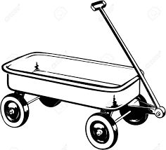
wagon
4
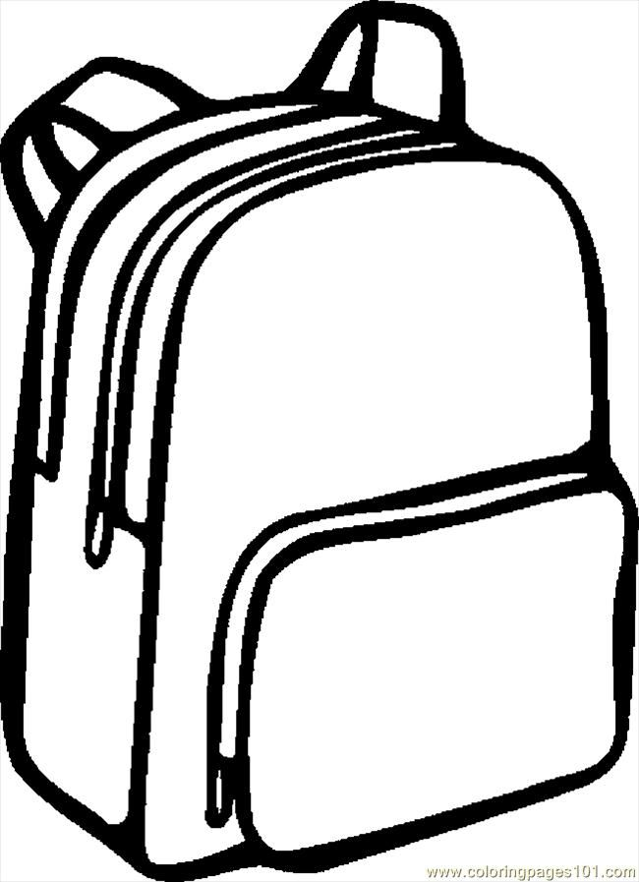
backpack
1
3
2
4
3
2
1

walrus
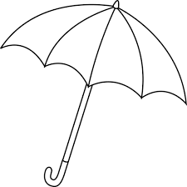
umbrella
banana

4
3
2
4
3
2
1
1
2
3
4
1

Read it. Trace it. Write it.
I I __

TUESDAY-
Say the word. Circle the picture that begins with the sound /m/.
bag

map
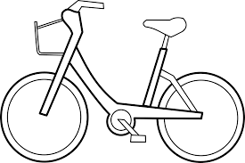
bike
mop
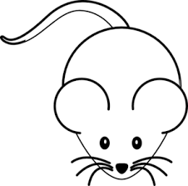
mouse

Practice forming the letter Mm.
M M M M M M
m m m m m m
THURSDAY- Say the word. Circle the picture that begins with the sound /s/.
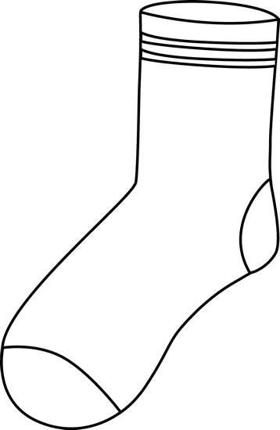
sock
six
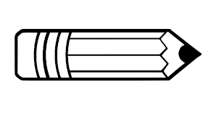
pencil
sun

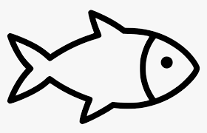
fish

Practice forming the letter Ss.
S S S S S S
s s s s s s s

Start Right Reader Week of Sept. 12-16
(Please let your child read this to you.)

Word to Know
I

Ss

I see the squirrel.

I see the seal.

I see the skunk.

I see the spider.

I see the snail. 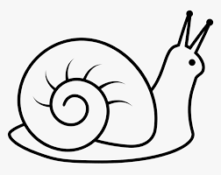

I see the snake. 